Creation of New VMs in Vcenter By Automation

Power Shell CLI Mode

* Install A Power shell CLI module 6.5 or updated module and then will lunch new VMs in Vsphere 6.5 V-center server by following below steps.

1. Open the window Power Shell CLI and check the latest version.

$PSVersiontable

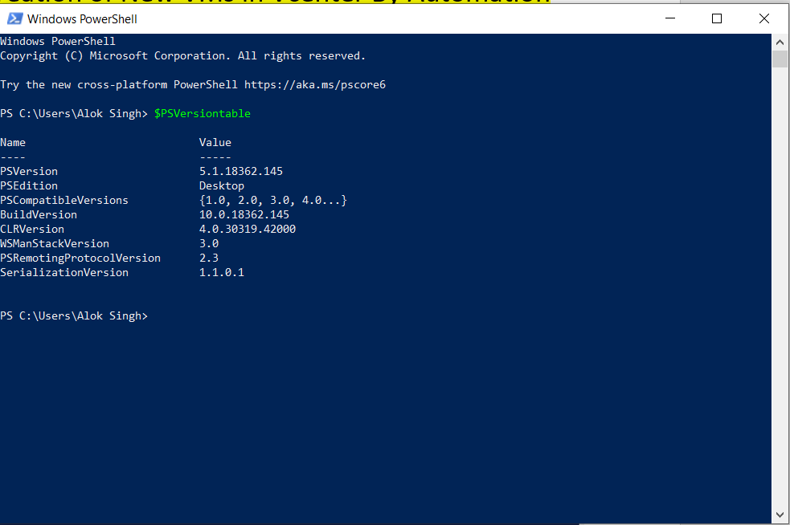

1. Find a new Module in power shell Galary using command Find-Module -Name VMware.PowerCLI

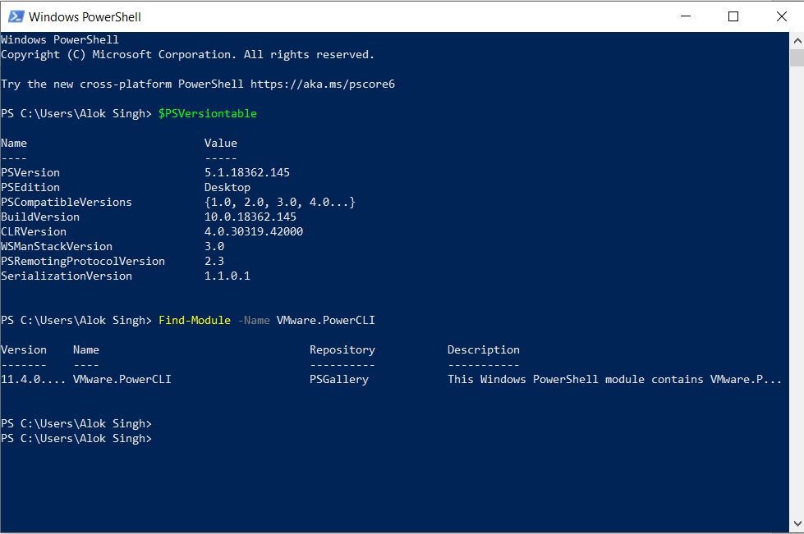

1. If Upadated Module is not installed, then Install a new module using command Install-Module -Name VMware.PowerCLI -Scope CurrentUser

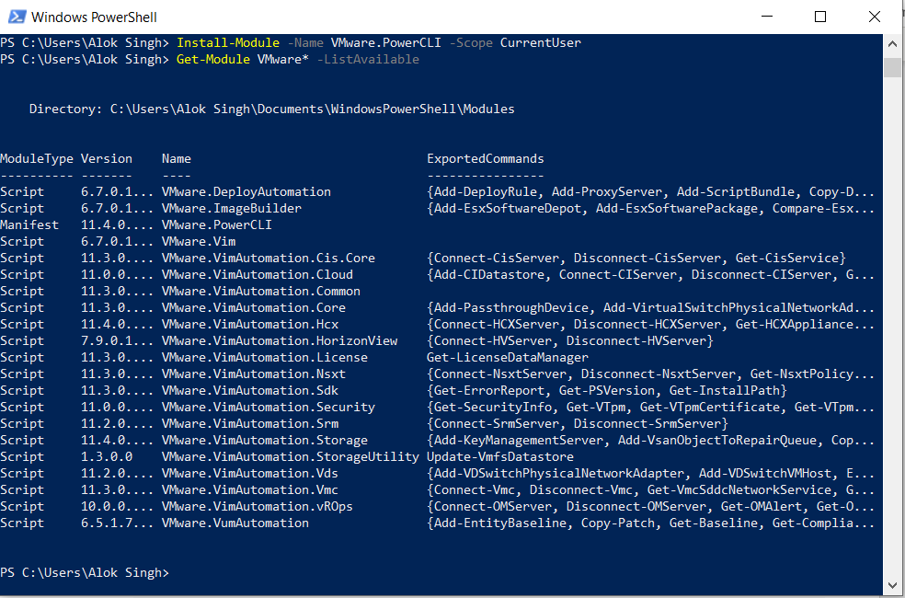

1. Now get new module using command Get-Module VMware* -ListAvailable



1. Now First Define the credentials for getting Login in that V-Center $usercreds = Get-Credential

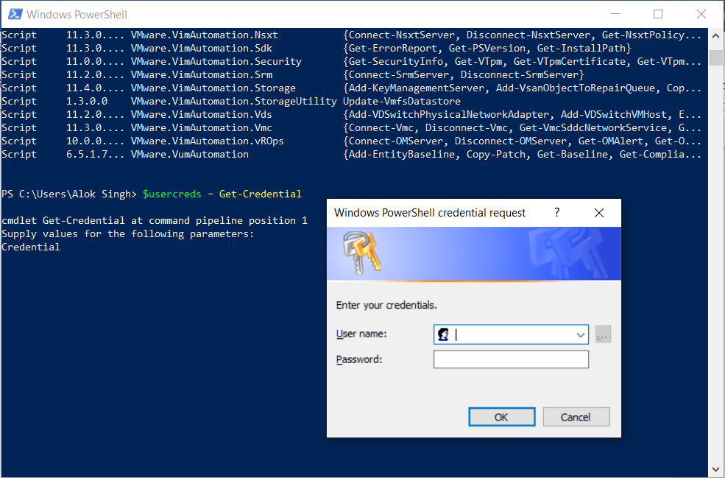

1. Then Connect the power shell to Vcenter Server using this Command connect-VIServer -Server 10.85.2.139 -Credential $usercreds -WarningAction SilentlyContinue

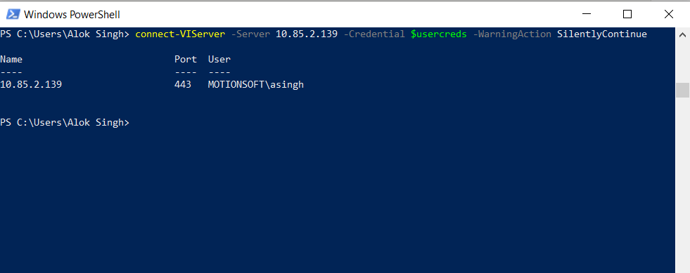

1. If You will get any certification error during above command so use this command to remove same error.

Set-PowerCLIConfiguration -InvalidCertificateAction Ignore

Then

Set-PowerCLIConfiguration -InvalidCertificateAction Ignore -Confirm:$false

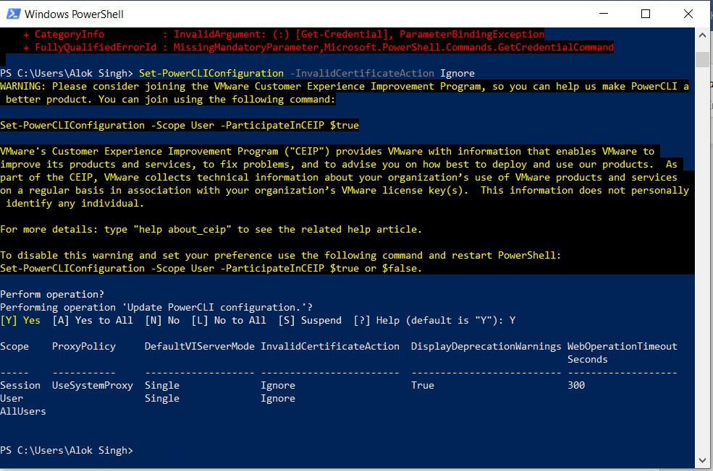

1. Next step is to write Power shell script for creation of New VMs in Vcenter.

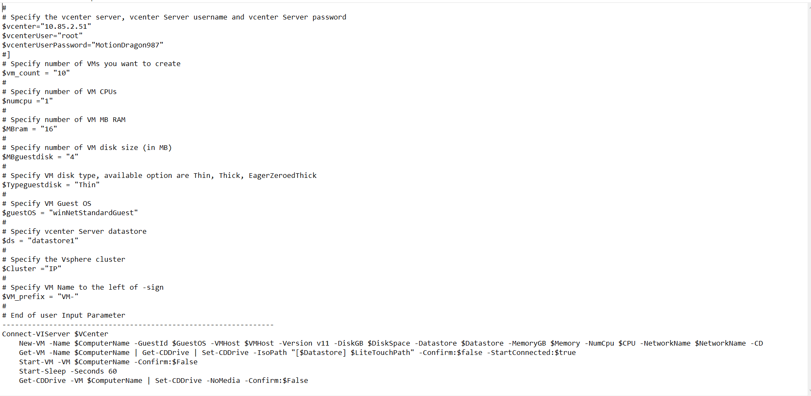

1. Now Run above Script in Power shell and then automatically the New VMs will be installed. On the Other Hand, we can use Window Power shell ISO (Integrated Scripting Environment) which is a graphical host application for windows power shell.

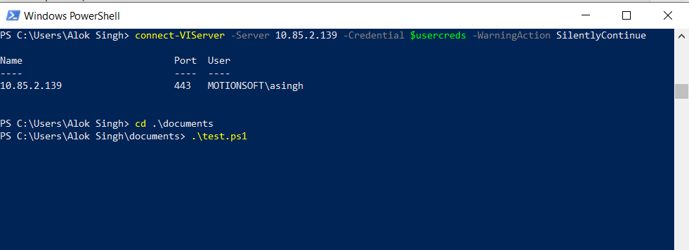

1. Now New VMs has been created so need to define Netwrk Adapter and to install Host OS by using ISO images using Below commands

**For Network Adapter**

$vm = Get-VM test027

Get-NetworkAdapter -VM $vm

Get-VM Test027 | New-NetworkAdapter -NetworkName "Management" -MacAddress '00:50:56:b8:8c:d2' -WakeOnLan -StartConnected -Type Vmxnet3

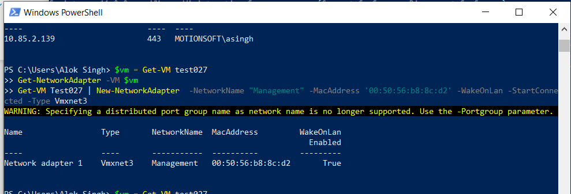

**For ISO Image**

----------------------------------------------

$vm = Get-VM test027

New-CDDrive -VM $vm -ISOPath "[EMC-M4024-A] Install/SW_DVD9_Win_Server_STD_CORE_2019_1809.1_64Bit_English_DC_STD_MLF_X22-02970.ISO"

-------------------------------------------------------------------------------------------------

OR

-------------------------------------------------------------------------------------------------

$cd = New-CDDrive -VM Test027 -ISOPath "[EMC-M4024-A]Install/SW_DVD9_Win_Server_STD_cORE_2019_1809.1_64Bit_English_DC_STD_MLF_X22-02970.ISO"

Set-CDDrive -CD $cd -StartConnected 1

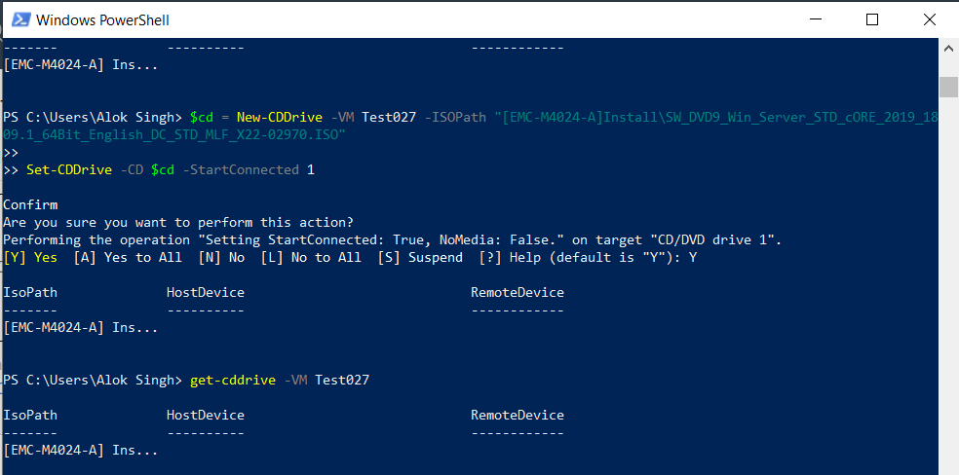

1. Either you can put both command into scripted file and run the same script so will get below outputs

